

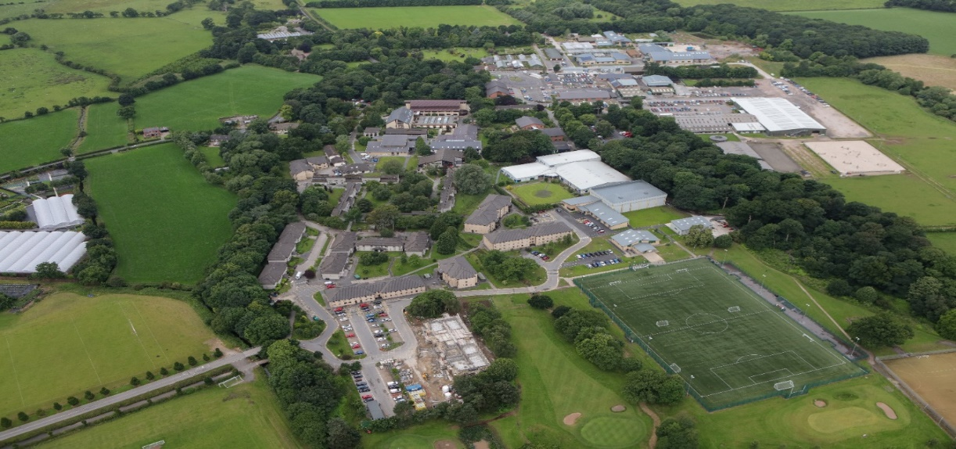

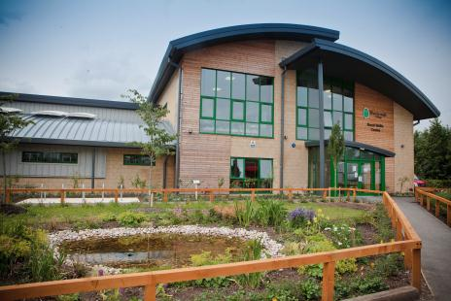 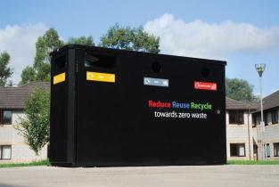

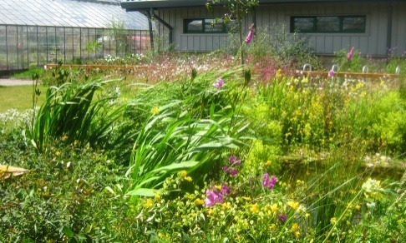

**Streamlined Energy and Carbon Reporting 19 – 20**

MARCH 2021

1. **Introduction**

Myerscough College is a specialist land-based, science, engineering and sports college operating from a large rural site situated north of Preston, Lancashire. The College also operates from several other centres across the North West. The estate occupied by the College is incredibly diverse in nature and includes: general and specialist teaching resources to support a wide range of pre-16, Further Education, Higher Education and Apprenticeship programmes; residential accommodation for learners living on campus; equine facilities which support both curriculum and commercial activities; golf course; and, agricultural and farming facilities, again to support both curriculum and commercial activities.

1. **Energy Use and Carbon Emissions Data for 19–20 Year**

|  |  |
| --- | --- |
| **Energy Consumption used to calculate emissions (kWh)** | **Current Reporting Year**  **Aug 19 – July 20** |
| **Electricity (kWh)** | 2,911,509 |
| **Heating Fuels (kWh)** | 907,228 |
| **Gas (kWh)** | 7,878,100 |
| **Transport Fuels (kWh)** | 577,441 |
| **TOTAL (kWh)** | 12,274,278 |

|  |  |
| --- | --- |
|  | **Current Reporting Year**  **Aug 19 – July 20** |
| **Scope 1 Emissions in metric tonnes tCO2e** |  |
| Gas tCO2e | 1449 |
| Heating Fuels tCO2e | 35 |
| Owned transport tCO2e | 276 |
| **Total Scope 1 tCO2e** | 1759 |
| **Scope 2 Emissions in metric tonnes tCO2e** |  |
| Purchased Electricity tCO2e | 679 |
| **Scope 3 Emissions in metric tonnes tCO2e** |  |
| Business travel in Employee Owned Vehicles tCO2e | 72 |
| **Total Gross Emissions tCO2e** | 2509 |
| **Intensity ratio (No. Staff)** | 888 |
| **Tonnes CO2e per Member of Staff** | 2.8 |

1. **Reporting Methodology**

**Reporting Period:** 1st August 2019 – 30th July 2020

This report has been completed on a voluntary basis as the College is not required to report its energy and carbon emissions within its Annual Report. This is the first year of SECR carbon reporting and as such this year’s report will form the Baseline Year for future reporting.

The College has followed the 2019 HM Government Environmental Reporting Guidelines. The Green House Gas (GHG) Reporting Protocol – Corporate Standards and the 2020 UK Government’s Conversion Factors for Company Reporting have been used in calculating the data.

The College operates from a number of local authority-controlled premises in Blackburn, Liverpool and Warrington. The College also utilises premises which form part of Old Trafford Cricket Club in Manchester. All energy consumption data for these premises has not been available and estimated data has been included for the Liverpool and Warrington centres. The area of these premises is small in comparison to the rest of the college estate. The College will seek to obtain all the necessary information and include it within next year’s report.

For several months during the year college activities where altered as a result of national pandemic restrictions. Therefore, the consumption data may not fully reflect a typical year.

1. **Intensity Measurement**

The selected intensity measurement ratio is total gross emissions in metric tonnes CO2e per staff member, the recommended ratio for the sector.

1. **Measures Taken to Improve Energy Efficiency**

The College has previously implemented a Carbon Management Plan which successfully reduced the carbon impact of its activities. Since completion, the benefits of the plan have continued as has the adoption of energy efficiency technology to further reduce carbon emissions.

During the reporting period the College has implemented a series of measures to reduce the carbon footprint from its activities.

* Continued adoption of reduce, reuse and recycle principles in order to minimise waste.
* Lighting efficiency improvements were completed within a number of buildings.
* Continued replacement of gas boilers with energy efficient models.
* Additional College controlled premises were constructed at Croxteth Park in Liverpool. These new facilities achieved BREEAM excellent standard and included energy efficiency measures such as a Building Management System, lighting control system and solar array.
* Purchased two all-electric zero emission vehicles.
* Installed vehicle telematics on college owned cars to support efficient management.

In previous years the College has implemented a wide range of carbon reduction measures. These have included power optimisation, installation of solar arrays on a range of buildings, installation of a combined heat and power unit and a number of biomass heating systems. Lighting has been updated in all buildings, older inefficient electrical appliances have been replaced, water consumption control measures introduced and paper consumption reduced through the adoption of technology solutions. A College wide reduce, reuse and recycle continues to operate and there has been good engagement from staff and students. Sustainability in all its forms is a strategic objective for the College and plans are now being developed to ensure that actions allow the achievement of government targets.